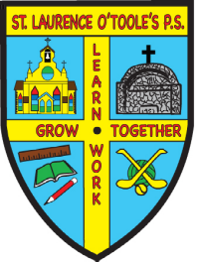 St. Laurence O’Toole’s P.S.

31 Main Street Belleeks Newry Co. Down BT35 7PH

PRINCIPAL: Mrs. B. Friel Tel: 028 30 878387
Fax: 028 30878387

Email: info@stlaurences.belleeks.ni.sch.uk
Website: www.stlaurenceotooles.co.uk

*Top Secret*

June 22, 2020

Dear Parents/Guardians,

As you may be aware, we are making plans to give our P7 leavers a “socially distanced” send–off this Friday. Circumstances have limited our options. However, the P7 parents have come up with the excellent idea of doing a “Drive By” and we are appealing to as many of you as possible to become involved.

The plan is to invite our P7 children into school at 1pm to pick up their “Leavers Bags”. We will let them have a last look around the school, sign old shirts (if they still have them!) and give them some light refreshments. This should take about half an hour or so. When we have had some time together with the children, we will send a message to one of the parents to let them know that we are in position and ready for the drive by. That’s when it is hoped that as many of you as possible will drive by honking horns etc. There are only 8 children in this year group and we trust you will support us in making this a memorable send-off for our P7s in these most unusual times. So please get involved and let’s make this a special school event for our Class of 2020.

Yours sincerely,

B. Friel
(Principal)

P.S. Please keep this a secret as we want to give our P7s a BIG surprise!

