Holidays 2020/2021

Monday 24th August (Induction Week) | School Opens  Autumn Term begins
Friday 18th September | School closes 1pm
Monday 21st – Friday 25th September | School closed
Monday 28th September | School reopens
Friday 23rd October | School closes 1pm
Monday 26th – Friday 30th October | School closed  Mid-term/Halloween
Monday 2nd November | School reopens
Wednesday 23rd December | School closes at 11am  Christmas break
Thursday 7th January | School Opens  Spring Term
Tuesday 16th February | School closes 1pm
Wednesday 17th – Friday 19th February | School closed  Mid-term
Tuesday 16th March | School closes 1pm
Wednesday 17th – Thursday 18th March | School closed  St. Patrick’s Bank Holiday
Thursday 1st April | School closes at 11am  Easter Break
Monday 12th April | School Opens  Summer Term
Monday 3rd May | School closed  Bank Holiday
Friday 28th May | School closes at 1pm
Monday 31st May – Friday 4th June | School closed  Bank Holiday/Mid term
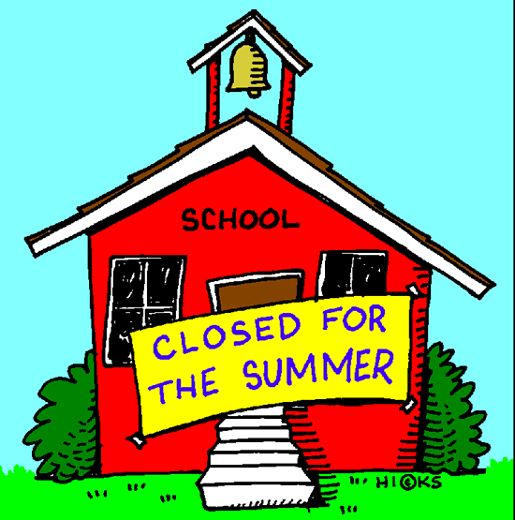  Wednesday 30th June | School Closes at 11am for Summer holidays

