Dear Parents/Carers/Boys and Girls, 22/12/20
I truly hope you are all well and looking forward to spending time together at Christmas. I sincerely hope that this current situation with Covid is not impacting TOO much on your plans and that you all are able to enjoy Chiristmas with your loved ones.
As you know I am under “Doctor’s Orders” and have been unable to come to work. However, I just wanted to take this opportunity to thank you all for being so supportive of the staff as always. I’m sure you will agree that they have all worked incredulously to keep things running as normal (as is possible!) for the children whilst ensuring their safety in these challenging times. I congratulate them for their absolute professionalism. I feel the little video that was uploaded last week summarises just how happy the children are in school albeit in very different days.
The children excelled themselves as they always do at this time of year and proved that, in the face of all, that they can still put on a brilliant and moving show. It certainly brought a tear to my eye and a huge smile as I watched it. I have to be very biased and mention the movers and groovers in P6 and P7. Didn’t realise that we had such cool characters in that classroom!!!
Boys and girls, I know I might say it every year but you are all AMAZING and myself and all the staff feel honoured to work with you and your families. I am sure that Santa will be VERY kind to you all. I miss you and will definitely get to see you shortly in 2021. Be good and remember to pray hard every day.
Anyway, I could not let the holidays pass without wishing you all a Very Happy Christmas and Peaceful New Year.
Please Stay Safe and God Bless you all.
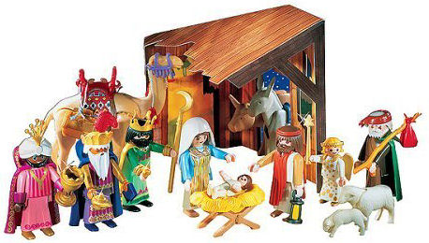

B. Friel

