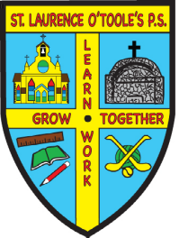 St. Laurence O’Toole’s P.S.

31 Main Street Belleeks Newry Co. Down BT35 7PH

PRINCIPAL: Mrs. B. Friel Tel: 028 30 878387
Fax: 028 30878387

Email: info@stlaurences.belleeks.ni.sch.uk
Website: www.stlaurenceotooles.co.uk

4th January 2021

Dear Parent/Carer,

I hope you all had a lovely Christmas and a very Happy New Year.

Following the Education Minister’s announcement, our reopening plans for term 2 have been amended. Primary school children will be learning remotely until Monday 11th January. The first day of the normal school term is to be used to prepare for this, therefore Thursday 7th January will be a staff planning day. Friday 8th January will be a remote learning day, teachers will be uploading work onto Dojo. We will then hopefully return to school for face to face teaching on Monday 11th January.

The department has stated that children of key workers (both parents) or vulnerable children may apply to come to school for ‘supervised learning’ doing the same activities as the children who are at home. If you feel that you require this provision for Friday 8th January as you have no other safe alternative please email atoner721@c2kni.net and I will forward you the form for completion. Requests for this service must be made by 6pm on Tuesday 5th January.

Yours sincerely,

Mrs A. Toner

