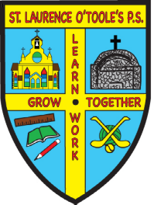 St. Laurence O’Toole’s P.S.

31 Main Street Belleeks Newry Co. Down BT35 7PH

PRINCIPAL: Mrs. B. Friel Tel: 028 30 878387
Fax: 028 30878387

Email: info@stlaurences.belleeks.ni.sch.uk
Website: www.stlaurenceotooles.co.uk

February 1st, 2021

Dear Parents,

I hope you are all becoming familiar with the structure of our remote learning system. We appreciate that it can be difficult for everyone and want to remind you that the work provided for the children is just a guideline. Only do as much work as you feel is appropriate for your children.

It is extremely important that we find a balance between academic work and looking after the wellbeing of the children. We recognise that many children need support for their health and wellbeing at the moment so we have included a selection of activities and suggestions in their work packs to assist with this. We will also be posting other ideas and tips on the Dojo on a regular basis. In addition, Joanne Callan our Relaxed Kids coach will be providing online sessions for our school. We hope you find this helpful.

As always please do not hesitate to contact us if we can be of any more assistance in any way.

Thank you for your continued support.

Yours sincerely,

Mrs. A Toner

