RORY’S MILES 2 MAYO

SEPTEMBER 8 - SEPTEMBER 17

THIS SEPTEMBER, FORMER IRELAND RUGBY CAPTAIN, RORY BEST WILL BE TAKING ON A MAMMOTH CHALLENGE TO HELP CHILDREN ACROSS IRELAND COPE WITH THE IMPACT OF A CANCER DIAGNOSIS.
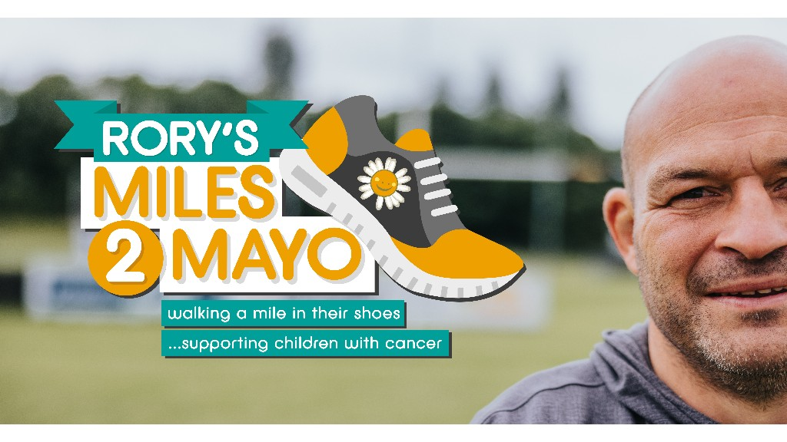

To mark Childhood Cancer Awareness Month, Rory will be shining a light on the experiences of children and young people by ‘walking a mile in their shoes’ or in this case, walking an epic 180 miles from Daisy Lodge in Co. Down to the site of Cancer Fund for Children’s new short break centre in Co. Mayo.
Rory’s ambitious trek will see him walk through a number of counties including his home county of Armagh as well as Fermanagh, Leitrim, Sligo, and Mayo to name a few. Rory is passionate about raising funds for Cancer Fund for Children who offer support to children across Ireland and aims to raise an amazing £500,000 but needs your help!

Rory is walking through Belleek village tomorrow, Thursday 9th September and the children will be standing out to cheer him on as he walks past the school.
We are asking parents to donate to this very important fundraiser.
Any contribution will be greatly appreciated. Please bring donation to school tomorrow morning.

Thank You

